Human-robot handshake
qb SoftHand
july, 5th
Dear all, the last time we talked about an open loop experiment where the softhand is set to a fixed position for a fixed amount of time, the human hand is in the handshaking position, and the FSR sensors are on and in their fixed position. Having this situation we want to record the behaviour of the human and correlate it with the softhand movements. Here my setup.
The following picture shows the time(seconds) vs. position (pseudo random)
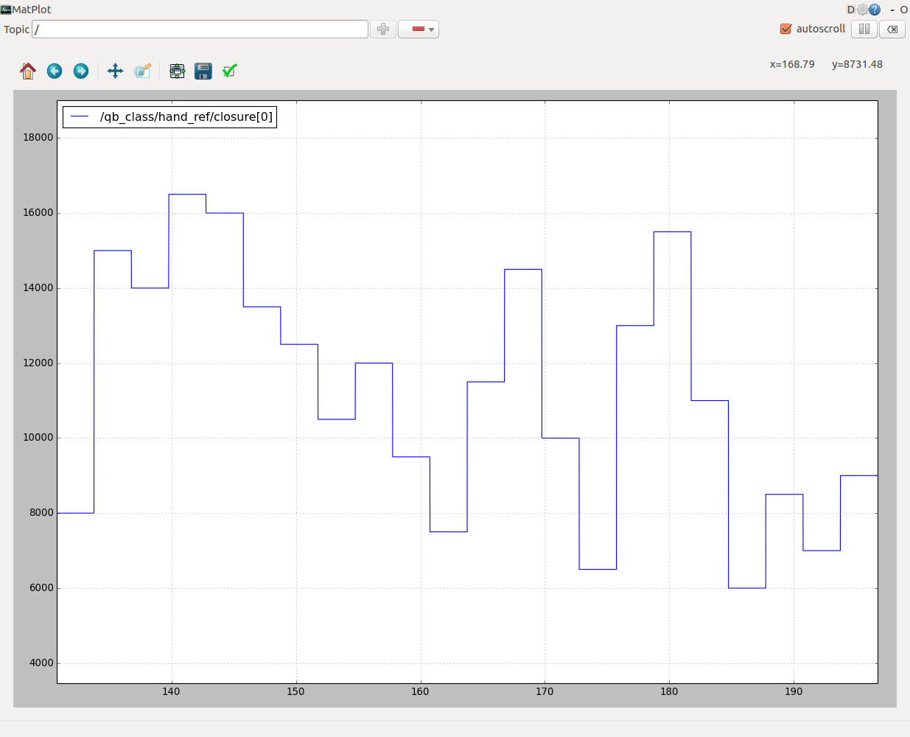Illustration 1: Referenced Position
The softhand is receiving 22 different positions from [6000 to 17000] with a step of 500. each position appears only once and lasts 3 seconds. The frequency rate is 100Hz so the whole experiment lasts 66 seconds.
The vector in which i'm storing the 22 values is shuffled using a fixed seed in order to have a pseudorandom order.
Here's a snippet of the code
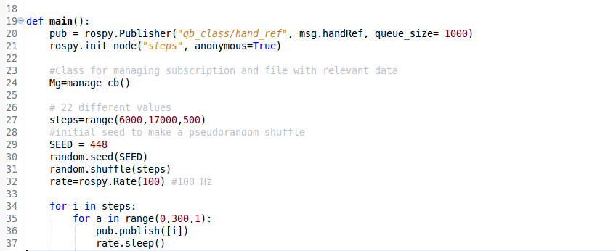
The seed value of 448 is chosen randomly but is fixed between experiments with different humans.
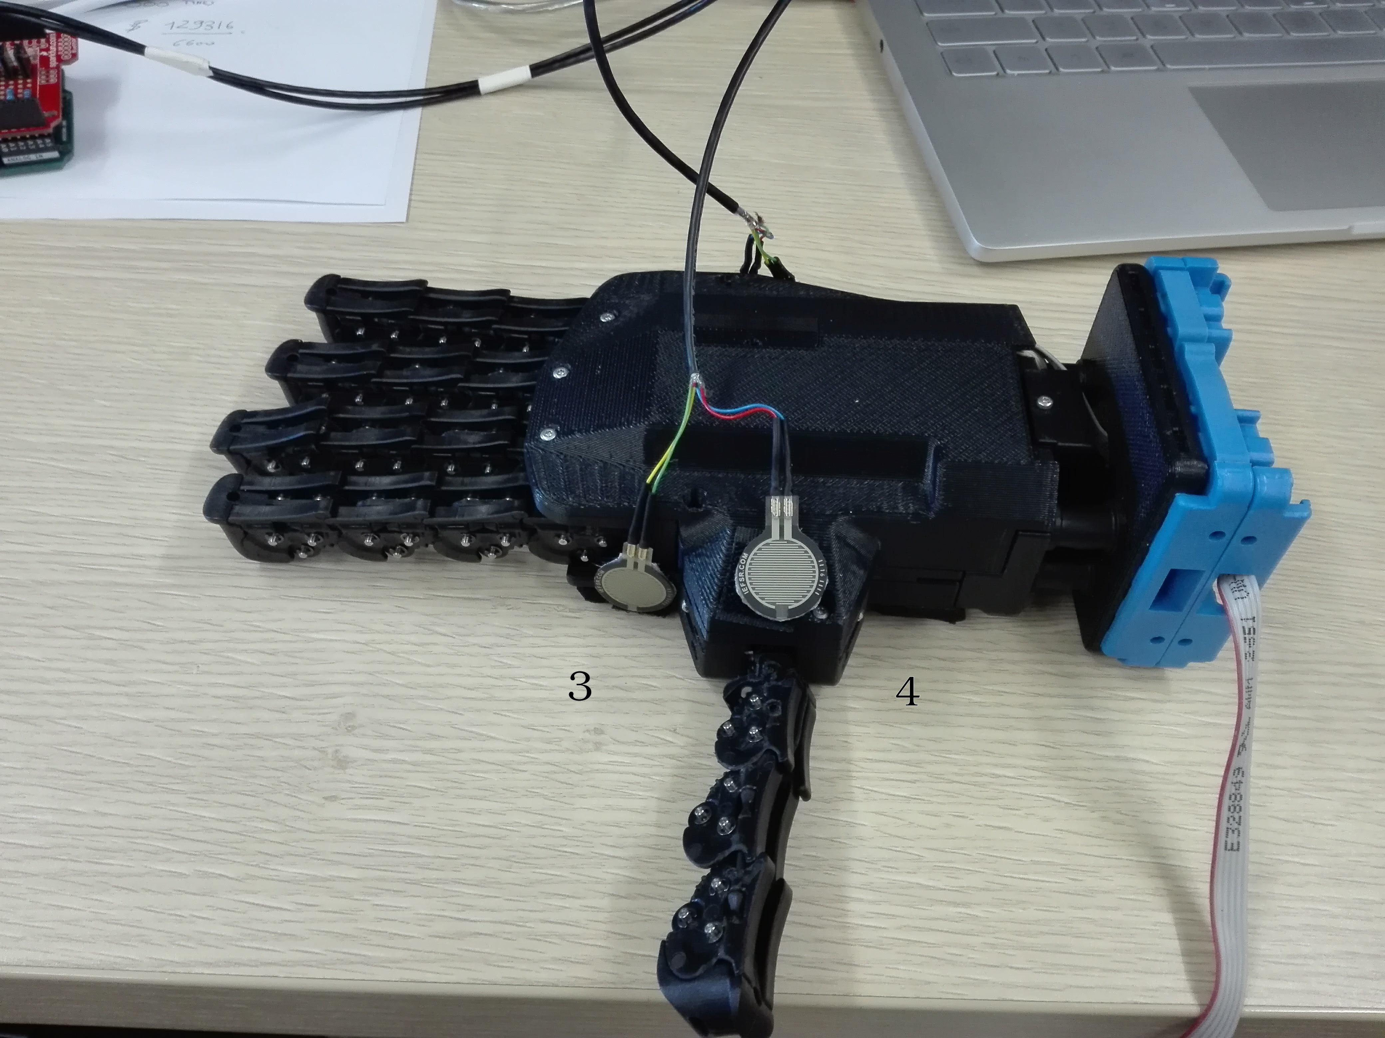
The physical position of the sensors and their id on the softhand is the following:
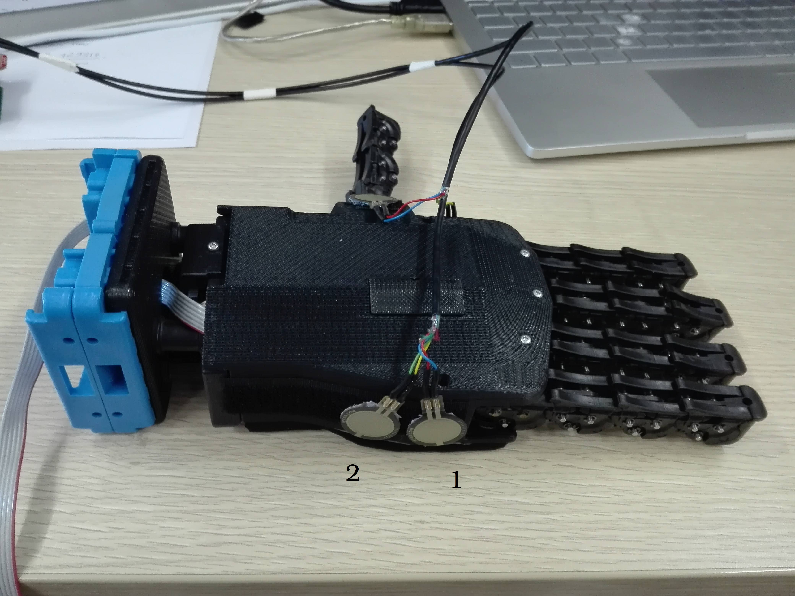

The value of the sensors during the experiment is the following:
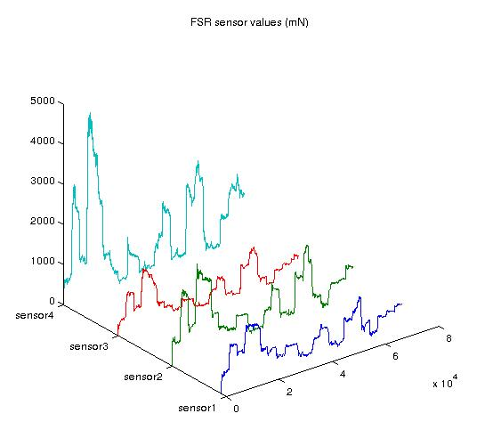

From this approach we can clearly notice that the sensor4 is the most relevant one, in its physical position is the only one which is reflecting the behaviour of the human thumb. If we compare the shapes of these curves with with referenced position in the Illustration 1: Referenced Position, we can appreciate a correlation at first sight. Analytical tools should now be used in order to evaluate the correlation.
The Picture below shows the Current absorbed by the softhand during the experiment, the Referenced position and the real position measured by the softhand.
The real position is trying to follow the referenced position but in this experiment we used a low stiffness (0.1), low proportional gain. If we increase the proportional gain to (f.i 0.7) the error between the positions tends to decrease.

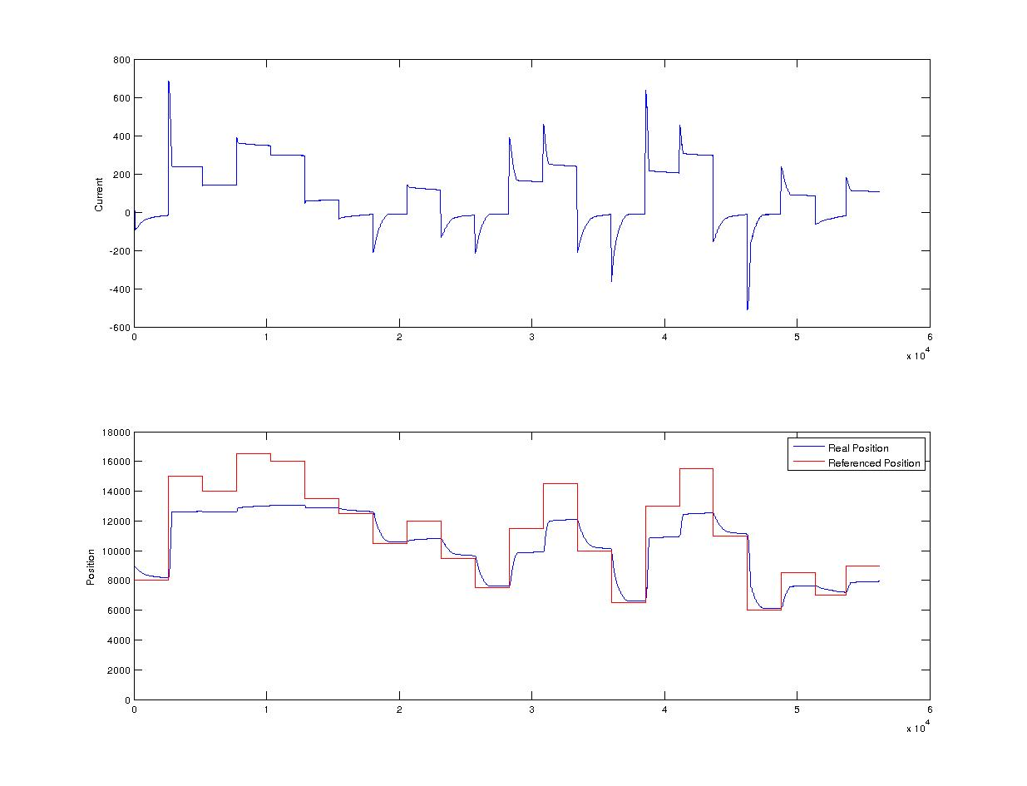Illustration 2: stiffness = 0.1
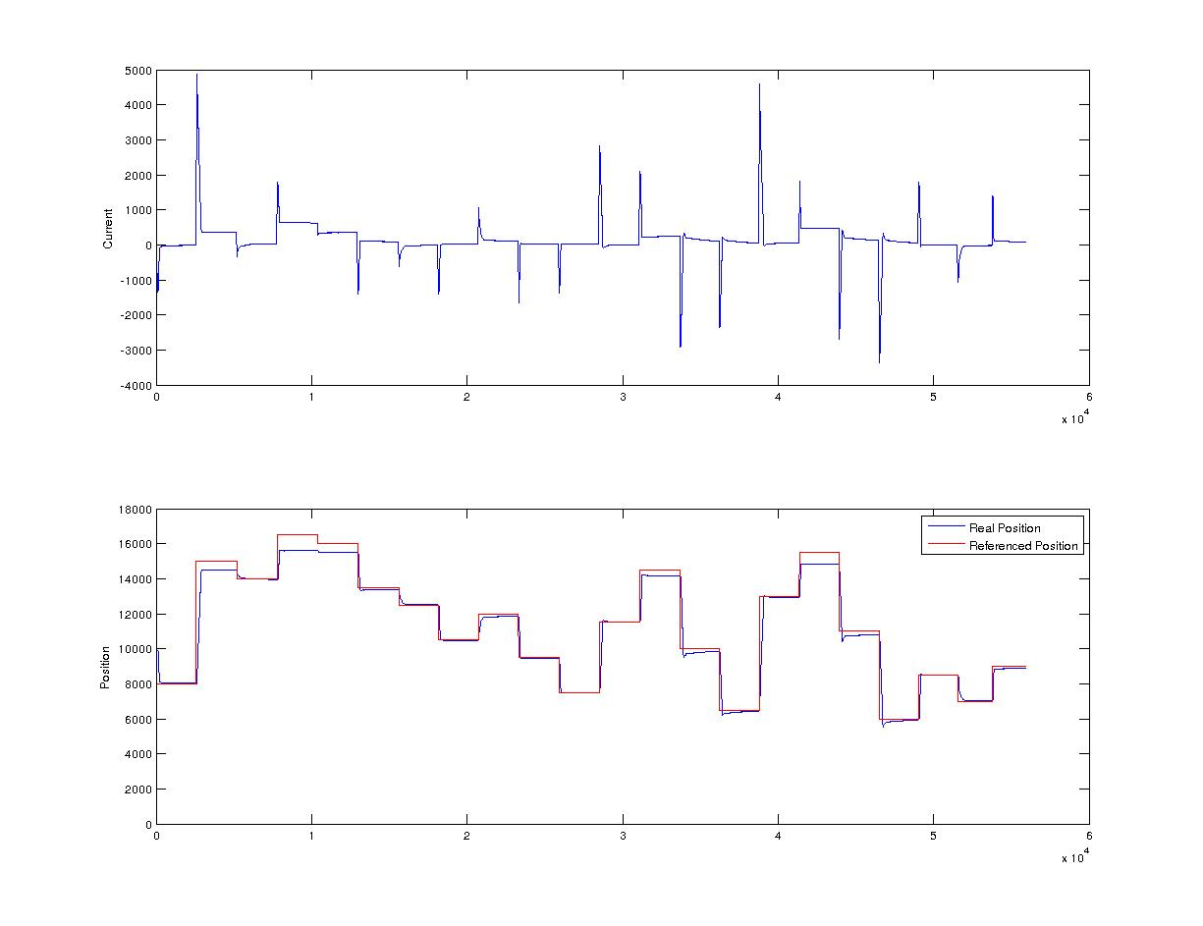Illustration 3: stiffness = 0.7
Increasing the stiffness is resulting in a less smooth current but more trusty position. Both the experiments last 66seconds. Is interesting to notice the x axis of the previous plots, the small difference in the x axis scale is due to the way i'm using to write the file. Each time a topic is publishing a value, a row is written to the file, this means that if the topics have different frequency rate the file will write the value of that topic and copy the previous values of the others. Modifying the stiffness is affecting the frequency of the softhand topic.
With stiffness = 0.1 the number of rows saved in the file are 56187
with stiffness = 0.7 the number of rows saved in the file are 55949

